73.05.22o
To James Casey
I73/9287, unit 750, VPRS 44/P inward registered and unregistered correspondence, VA 538 Department of Crown Lands and Survey, Public Record Office, Victoria.

MELBOURNE BOTANIC GARDEN.
APPLICATION FOR SUPPLY.

Reverend Edward Nolan
of St Patrick's College
requests that he may be supplied with the following plants
from the Melbourne Botanic Garden for Roman Catholic College at Kew

LIST.
Space for a large number, say 1000
X several hundred plant of trees & shrubs, miscellaneous

Recommended already for approval to the Honorable the Minister, as far as available. 5/5/73
F.v.M

9/4 1873 Signature of Applicant Ed. Nolan
__________________________________________________________________
The items marked (X) can be supplied.

Melbourne Botanic Garden, 22 May 1873. Ferd. von Mueller Director.
__________________________________________________________________
Received from the Gardens the above items, as marked approved.

187
___________________________________________________________________
Notice. — No plants, cuttings, or seeds will be issued from these Gardens unless in exchange, or for public institutions or benevolent purposes.

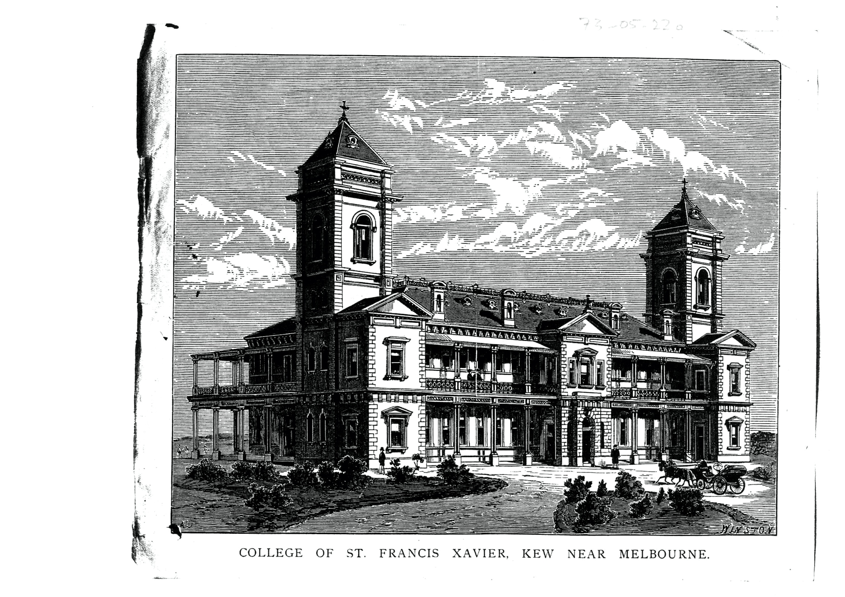

East Melbourne.
MS is accompanied by a printed black-and-white print 73-05-22o_image01.jpg captioned 'COLLEGE OF ST FRANCIS XAVIER, KEW NEAR MELBOURNE' The image is of the intended building, for which foundations were laid in 1872, with the building being sufficiently complete to take students in 1878 (https://www.xavier.vic.edu.au/our-xavier-history, accessed 16 December 2021).
M had submitted Nolan's application with M to J. Casey, 19 May 1873.

